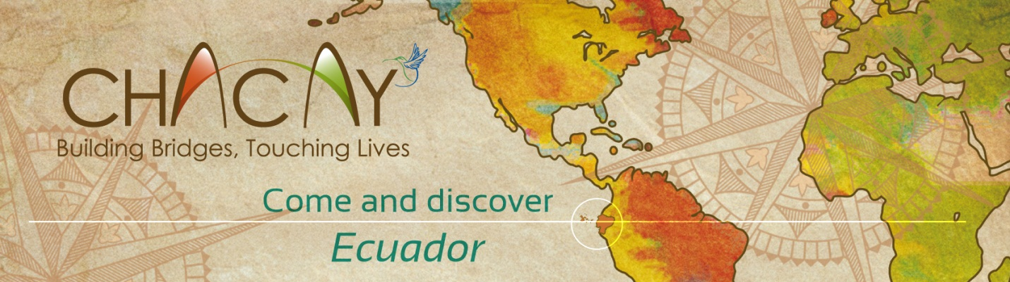
ENCUENTROS 2013: AN UNFORGETTABLE, TRANSFORMATIONAL SUMMER
BIENVENIDOS A ECUADOR!

Have you ever:
Practiced Spanish in a home stay with an Ecuadorian family?
Climbed a 4800 meter (14000 foot) volcano at sunrise?
Had a spider monkey snuggle with you, and then make off with your cell phone?
Watched whales breach in the Pacific Ocean?
Traveled from the Amazon through the Sierra to the Pacific Ocean in a single day?
Frolicked underwater with a sea lion in the Enchanted Isles of Galapagos?
Worked in a chocolate factory in picturesque Salinas de Guaranda?
Taught English and computer skills to high school students in the Amazon jungle?
Program focus:Leadership, Conservation, Community service, Public Health
Come to Ecuador, an extraordinary bio-diverse and cultural wonderland, for a month guaranteed to change your life! July 1st to 31st, with the option of an additional week on the Galapagos Islands
Ecuador, one of the smallest countries in South America, is also one of the most biologically and culturally diverse in the world. The Andes Mountains divide the country into three regions: Amazonia, Sierra and Costa; a fourth, the Galapagos Islands, also lie on the equator 1000 miles away in the Pacific.
The total cost of the program excluding the Galapagos portion is $3500, and covers room and board, home stays, educational activities, excursions, and all local transportation expenses. It does not include air travel to and from Ecuador, or travel and health insurance. A $500 deposit guarantees a place in the 2013 program. An early bird discount, for those who sign up by March 31, is available for $3200! We are also offering a $200 finder’s fee for every additional participant you recruit for Encuentros 2013.
The balance of $3000 ($2700 for early bird inscription) is due April 30th. Ten percent of the cost goes toward community development in Ecuador. For those interested in week five in Galapagos, the cost is an additional $1500 (includes air fare and park entrance fees).
The program begins in Quito on Monday, July 1, and participants return home on Tuesday, July 31st, with flexibility on travel dates to allow for lowest air fares. The Galapagos portion is from July 31st to August 7.
To apply, contact David Lansdale at
david@chacay.com
From US, dial 1-888-776-6802
Skype Username: dplansdale
Chacay, Inc.
19 Sears Road
Newfane, Vermont 05345
Phone/Fax: 802 365 7968
www.chacay.org

